**APPLICATION ENVIRONMENTS**

* Environment means the platform which is used to run our application
* In Real-time, we will use multiple environments to run our application
* DEV Environment
* SIT Environment
* UAT Environment
* PILOT Environment
* PROD Environment

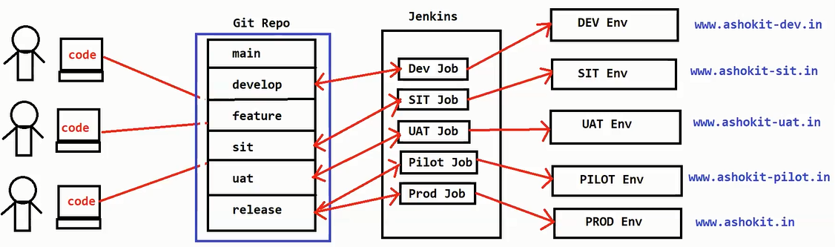

* Developers will use DEV environment for integration testing.
* SIT environment will be used by Software Testing team to test our application functionality. SIT stands for System Integration Testing.
* UAT means User Acceptance Testing. UAT will be done by Client. For client testing we will give UAT environment.

**Note:** After UAT testing, client will decide GO or No-GO. GO means go for production deployment. No-GO means production deployment cancelled.

* When client identify some critical bugs in UAT then they will say No GO.
* PILOT environment is called as pre-prod environment. It is used for live data testing.
* PROD environment is called live environment. The application which is deployed in PROD environment will be available for public user’s access.

**Note: To deploy the project into these environments we will use Jenkins software.**